MICHIGAN CITY AREA SCHOOLS
SECLUSION AND OR RESTRAINT INCIDENT REPORT
Students Name: _______________________________________________________________
Racial/Ethnic Status of Student: _________________________________________
School: ______________________________________________ Grade: _________
Date and Time of the Incident: ___________________________________________
Parent Notification: Time: ____________ Date: ____________________________
Does the student have a disability? Yes: _____ IEP or Section 504 Plan (underline) No: _____
______________________________________________________________________
The following must be completed after each seclusion and/or restraint incident.
- A description of any relevant events leading up to the incident;

- A description of any interventions used prior to the implementation of seclusion or restraint;

- A description of the incident and/or student behavior that resulted in implementation of seclusion or restraint including a description of the danger of injury which resulted in the seclusion or restraint
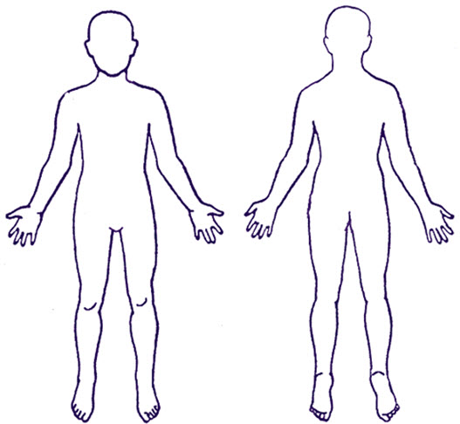
- The duration of any seclusion or restraint; or the beginning and ending times of the restraint and/or seclusion;

- A log of the student's behavior during seclusion or restraint, including a description of the restraint technique(s) used and any other interaction between the student and staff;

- A description of any injuries (to students, staff, or others) or property damage;

- A description of the planned approach to dealing with the student's behavior in the future;

- A list of the school personnel, who participated in the implementation, monitoring, and supervision of seclusion or restraint and whether they had training related to seclusion or restraint;

Comments:

This report must be forwarded to the Director of Special Education within 2-days of the event.

